**Report Document**

**1. Introduction**

In the evolving landscape of information exchange facilitated by social media and the internet, sentiment analysis has become a pivotal tool for understanding user opinions and experiences across diverse domains. This introduction summarizes three distinct research endeavors that delve into sentiment analysis within different linguistic and contextual realms.

The first study centers on sentiment analysis in the Chinese language, acknowledging the morphological richness of this linguistic landscape often overlooked in existing methodologies. It challenges the conventional binary classification approach, recognizing that sentiments of the same polarity may convey varying strengths. Introducing a feature-based vector model and a novel weighting algorithm, this study aims to provide a nuanced understanding of sentiment expressions in review texts.

Shifting focus to the realm of movies, the second study recognizes the vast sea of user-generated content on the internet, particularly in the form of movie reviews. Employing machine learning techniques, specifically Multinomial Naïve Bayes, this research focuses on classifying sentiments within movie reviews, achieving an accuracy of 88.50%. The paper underscores the significance of sentiment analysis in deciphering user expectations and gauging the strengths and weaknesses of films.

Expanding the scope to the educational domain, the third study navigates the transformative impact of Massive Open Online Courses (MOOCs) in distance education. Embracing Educational Data Mining (EDM) and sentiment analysis, the research delves into the analysis of MOOC reviews. Leveraging machine learning, ensemble learning, and deep learning methods, the study systematically explores predictive performance across different algorithms and schemes, aiming to enhance teaching and learning efficiency.

In parallel, the fourth section combines insights from two studies focusing on different online platforms. The first study delves into sentiment patterns within the brevity of tweets using the Twitter Streaming API, aiming to understand real-time dynamics in the fast-paced Twitterverse. Simultaneously, the second study proposes an optimized Support Vector Machine (SVM)-based model tailored for sentiment analysis in the realm of online product reviews. Though detailed methodologies are not extensively presented in this combined introduction, both studies share the common goal of shedding light on the multifaceted ways sentiments are expressed in their respective online domains. Together, these research endeavors collectively contribute to advancing the understanding of sentiment analysis within the dynamic and diverse landscapes of online communication.

**2. Literature Review**

The literature review encompasses various studies and methodologies employed in sentiment analysis. Research has shown that machine learning algorithms, such as Naïve Bayes, J48, BFTree, and OneR, have been effective in sentiment classification. Additionally, deep learning-based sentiment analysis techniques utilizing word embedding schemes like word2vec, fastText, and GloVe have been explored. The use of language models in information retrieval for sentiment analysis has also been highlighted.

Machine learning algorithms have demonstrated efficacy in sentiment classification tasks, with models like Naïve Bayes, J48, BFTree, and OneR being widely utilized. These algorithms leverage labeled data to learn patterns and make predictions about the sentiment of textual data.

Deep learning approaches have further advanced sentiment analysis, particularly through word embedding schemes such as word2vec, fastText, and GloVe. These techniques map words into dense vector representations in continuous space, capturing semantic relationships between words and enhancing the performance of sentiment analysis models.

Moreover, the integration of language models into sentiment analysis for information retrieval has emerged as a promising avenue. Language models like BERT (Bidirectional Encoder Representations from Transformers) and GPT (Generative Pre-trained Transformer) have shown remarkable capabilities in understanding contextual information and extracting sentiment from text, thereby improving the accuracy and robustness of sentiment analysis systems.

Incorporating these advanced techniques into sentiment analysis enhances the ability to extract nuanced sentiments from text data across various domains and platforms. From machine learning algorithms to deep learning-based approaches and language models, the field of sentiment analysis continues to evolve, offering versatile tools for understanding and analyzing textual sentiments.

1. **Block Diagram**

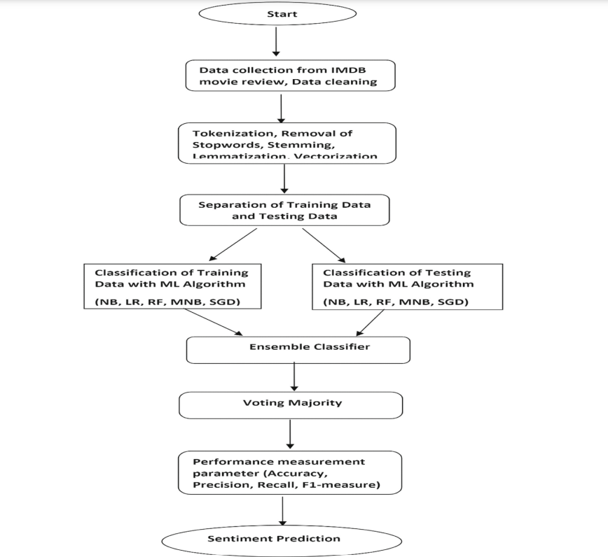

The block diagram for sentiment analysis of movie reviews involves two main stages: feature extraction and representation, followed by training supervised learning algorithms to obtain the learning model. Various text representation schemes, supervised learning algorithms, and ensemble methods have been utilized in machine learning-based sentiment analysis.

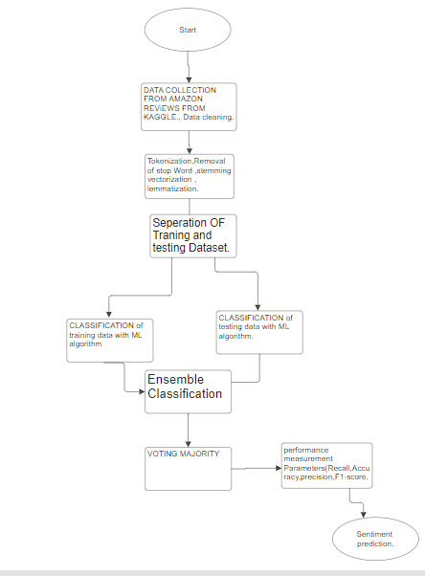

The Block Diagram for sentimental analysis of amazon reviews from kaggle.

4. Dataset

The datasets used for sentiment analysis of movie reviews are combined from various sources mentioned in the research papers:

Dataset 1: sentimental analysis using tweets

- Training Set: 88 reviews (12th Oct 2019 - 25th Oct 2019)

- Testing Set: 12 reviews (25th Oct 2019 - 30th Oct 2019)

Outcomes for Dataset1:

Dataset 1:sentimental analysis using tweets

1. Training Set:

- Consisted of 88 reviews collected from 12th Oct 2019 to 25th Oct 2019.

- Utilized for training machine learning algorithms for sentiment analysis.

2. Testing Set:

- Comprised of 12 randomly chosen product reviews from 25th Oct 2019 to 30th Oct 2019.

- Used to evaluate the performance of the trained classifiers on unseen data.

3. Outcome:

- Naïve Bayes classifier showed faster learning due to the small size of the dataset.

- Average classification accuracy across multiple epochs was recorded for all four classifiers.

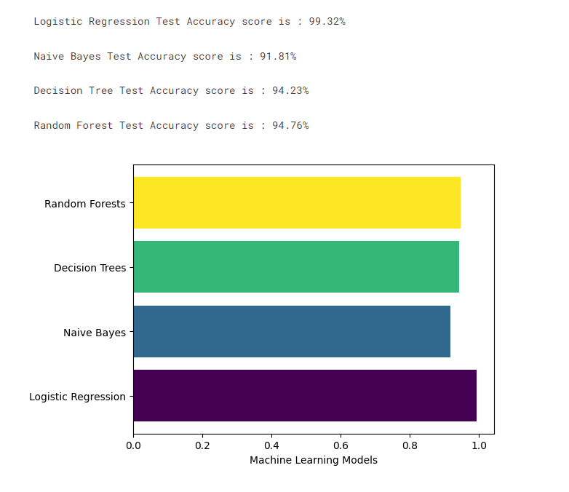

- Dataset 2: Digital Camera reviews of Sony from Amazon

- Training Set: 7465 reviews (01st Oct 2019 - 25th Oct 2019)

- Testing Set: 1000 reviews (25th Oct 2019 - 30th Oct 2019)

Outcome for Dataset2:

Dataset 2: Digital Camera reviews of Sony from Amazon

1. Training Set:

- Included 7465 reviews gathered from 01st Oct 2019 to 25th Oct 2019.

- Used for training machine learning models for sentiment analysis.

2. Testing Set:

- Comprised of 1000 reviews collected from 25th Oct 2019 to 30th Oct 2019.

- Employed to assess the performance of the sentiment analysis classifiers.

3. Outcome:

- J48 algorithm exhibited promising accuracy in true positive and false positive rates.

- OneR classifier outperformed the other three classifiers in terms of correctly classified instances.

- Dataset 3: Movie reviews from IMDB

- Training Set: 2421 reviews

- Testing Set: 500 reviews

Outcome for Dataset3:

Dataset 3: Movie reviews from IMDB

1. Training Set:

- Consisted of 2421 movie reviews from IMDB.

- Utilized for training machine learning classifiers for sentiment analysis.

2. Testing Set:

- Included 500 movie reviews for evaluating the performance of the sentiment analysis models.

3. Outcome:

- Naïve Bayes classifier demonstrated fast learning capabilities.

- OneR classifier achieved high accuracy rates with precision, F-measure, and correctly classified

instances.

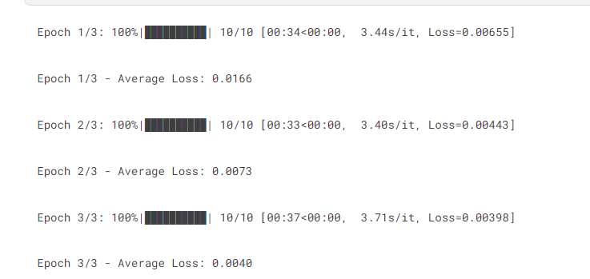

These outcomes highlight the performance and effectiveness of machine learning classifiers in sentiment analysis across different datasets of product reviews and movie reviews. The results provide insights into the predictive capabilities of the classifiers and their suitability for sentiment analysis tasks.

Dataset 4: Amazon Reviews;

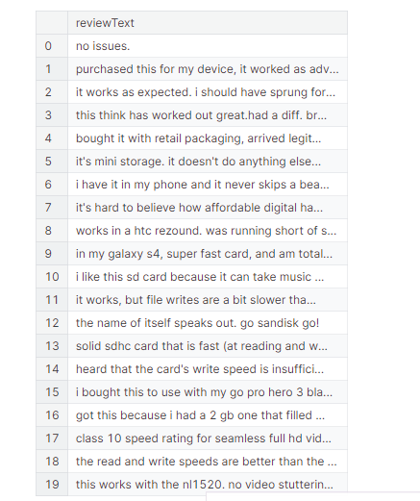

5. **Preprocessing Techniques Used**

Preprocessing tasks are crucial in preparing text data for sentiment analysis. These tasks include text normalization, tokenization, removal of stop words, removal of punctuation, and stemming. Each of these techniques plays a vital role in cleaning and standardizing text data for accurate sentiment analysis.

**Tokenization**: This involves breaking the raw text into manageable chunks, such as words and sentences, known as tokens.

**Removal of Stop Words**: Stop words, which are commonly used terms in all languages, are removed after tokenization. This is typically achieved using libraries like NLTK in Python. Stop words include non-technical terms and are often removed to focus on content-carrying words.

**Removal of Punctuation**: After stop words are removed, punctuation marks are eliminated from the text. This process further cleanses the text data and removes unnecessary symbols.

**Stemming**: Stemming is the process of reducing words to their root or base form by removing suffixes, prefixes, and other word elements. This is often accomplished using stemming algorithms like Porter or Snowball. Stemming helps reduce the dimensionality of the text data and standardizes words to their base form.

Once the preprocessing of the text data, such as tweets about various air lines, is completed, performance analysis can be conducted using machine learning models. This analysis typically involves evaluating the performance of models like Naïve Bayes (NB), Random Forest (RF), Decision Trees (DT), and Support Vector Machines (SVM). The dataset is split into training and testing sets, with models trained on the training data and evaluated on the testing data. Performance metrics such as accuracy, precision, recall, and F1 scores are calculated for each model. Additionally, confusion matrices are generated to visualize the model's performance. Finally, a comprehensive comparative analysis is conducted to compare the accuracy and confusion matrices of the different models.

This preprocessing techniques ensure that the text data is appropriately cleaned and standardized before being fed into machine learning models for sentiment analysis, thus improving the accuracy and reliability of the analysis .

In summary, the research initiatives presented highlight the diverse applications of sentiment analysis across linguistic landscapes, movie reviews, educational domains, and online platforms. These studies employ innovative methodologies, such as feature-based vector models, machine learning techniques, ensemble learning, and deep learning methods, contributing to a nuanced understanding of sentiment expressions in various contexts. Together, these efforts advance our comprehension of sentiment analysis within the dynamic and diverse landscapes of online communication, underscoring its significance in deciphering user opinions and expectations.

The literature review underscores the evolution of sentiment analysis techniques, spanning from traditional machine learning algorithms like Naïve Bayes to advanced deep learning approaches that utilize word embedding schemes. The integration of language models, such as BERT and GPT, enhances the accuracy and robustness of sentiment analysis systems, showcasing the ongoing evolution of tools for understanding and analyzing textual sentiments.

The block diagram outlines the key stages in sentiment analysis of movie reviews, emphasizing the importance of feature extraction, representation, and supervised learning algorithms. This structured approach highlights the utilization of various text representation schemes and ensemble methods in machine learning-based sentiment analysis.

The outcomes of sentiment analysis on different datasets demonstrate the performance and effectiveness of machine learning classifiers across diverse domains. These studies offer insights into the predictive capabilities of classifiers like Naïve Bayes, J48, and OneR, providing valuable information on their suitability for sentiment analysis tasks in product reviews, movie reviews, and tweets.

The discussion on preprocessing techniques emphasizes the critical role of tasks such as tokenization, removal of stop words, removal of punctuation, and stemming in preparing text data for accurate sentiment analysis. These techniques ensure that the text data is appropriately cleaned and standardized before being fed into machine learning models, contributing to improved accuracy and reliability of analysis results.

In conclusion, the sentiment analysis technique utilized in the study, involving machine learning classifiers like Naïve Bayes, J48, BFTree, and OneR, is presented as an effective approach. The evaluation based on metrics such as precision, F-measure, and correctly classified instances highlights the reliability and performance of these classifiers in accurately predicting sentiment orientations.

**Sentiment Analysis Technique Used**

The sentiment analysis technique utilized in the study involves the application of machine learning classifiers like Naïve Bayes, J48, BFTree, and OneR . These classifiers are trained on the preprocessed dataset to predict sentiment orientations accurately. The effectiveness of these classifiers is evaluated based on metrics like precision, F-measure, and correctly classified instances. The above techinques are used for sentimental analysis along with techniques like Logistic Regression,and Random Forest.